**CS107 Project Proposal**

Project Name: Sets game development

Team member: Dylan Soemitro, Mujie Wang, Xiaorong Wang

<https://www.setgame.com/set/puzzle>

**Background**:

Set is a puzzle game with 81 different cards. Each card has four attributes: number, color, shade, and shape. Each attribute has three categories (see table below). Three cards are a “set” if and only if for each attribute, they either all fall into the same category (e.g. they are all green), or they all fall into different categories.

**Project aim:**

In this project, we will create a modified game that is based on the rules of “Sets”. We will initiate the game with randomly generated cards of different features (see game “Sets”). We will give hints to the users of the card they should click if they have not made any moves in 60 seconds. After 60 seconds, the program will highlight one card that has the most sets containing it. After another 30 seconds, the program will highlight another card that is in the same set.

**CS knowledge:**

1. We will generate a set of cards of user-defined size (E.g. 3*4). Each card will resemble the ones in the game “Sets” with distinct features. (There will be more user defined parts such as choosing the difficulty depending on the size)
2. Based on the cards and the patterns on the card that we have generated, we will be using a graph-like data structure to store all of the available ‘sets’. It is “graph-like” as for each edge in the graph, it contains three nodes, as opposed to in normal graph each edge contains 2 nodes.

The nodes will have the following arguments:

|  |  |  |  |
| --- | --- | --- | --- |
| **Number of shapes** | **Color** | **Shade** | **Shape** |
| 1 | Red | Empty | Diamond |
| 2 | Green | Lined | Squiggle |
| 3 | Purple | Shaded | Oval |

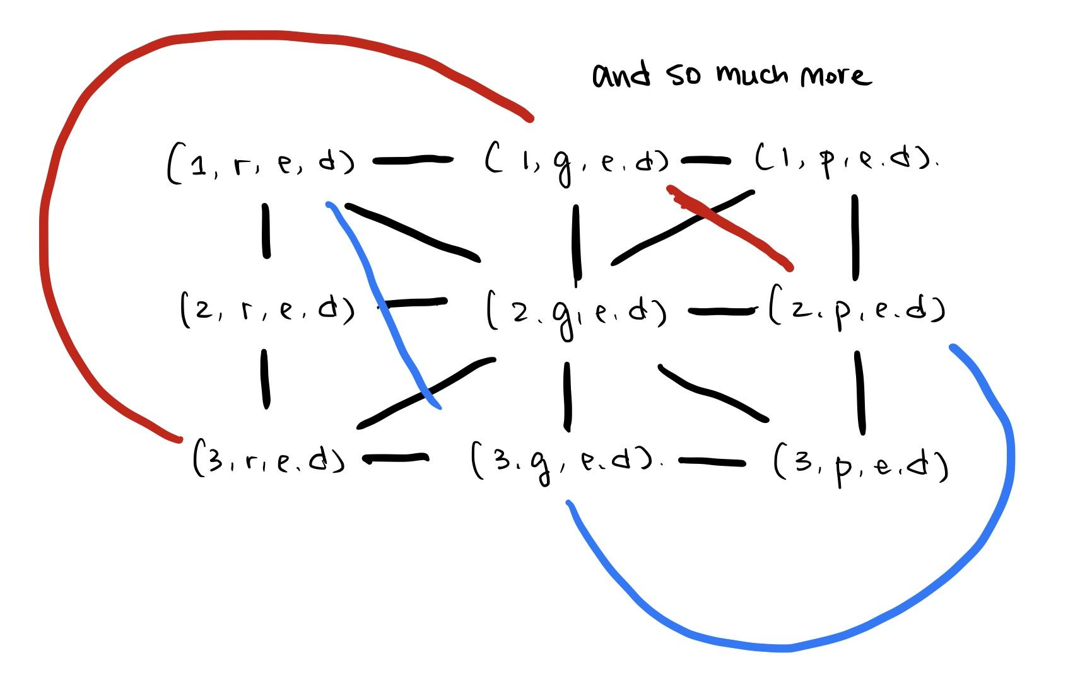

1. We will be using Pygame modules to display the game. Specifically, we will highlight the card that we want to hint the player.

**Timeline:**

Nov.18 - Nov.21 Proposal and general idea of the project

Nov.22 - Nov.26 Finish the establishment of the graph before thanksgiving.

Nov.27 - Dec. 6 Individually working on 1. The generation of sets of cards (definition) 2. Two of us will be working together on the implementation of the game and to deal with the different choices of user choices

Dec.7 - Dec.9 Prepare for final presentation

**Risks:**

1. The creation of the matrix might be too slow to finish in 60 seconds where we are suppose to give hints.
2. This is a game that many people have already developed and many similar things are available on the Internet.
3. The use of pygames as a completely new package